MINI PROJECT

(2022-2023)

“**Philia-A Chat Application**”

Project Report



Department of Computer Engineering & Applications

**Institute of Engineering & Technology**

**SUBMITTED TO- SUBMITTED BY-**

**Mr. Mayank Saxena Ankur Gautam**

**(Technical Trainer) (201500102)**

**GLA University**

**Mathura- 281406, INDIA**

**2022**

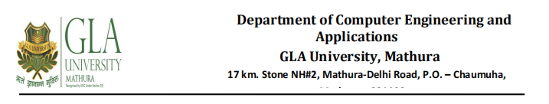

**Declaration**

I/we hereby declare that the work which is being presented in the Bachelor of technology. Project **“Philia- A Chat Application”**, in partial fulfilment of the requirements for the award of the ***Bachelor of Technology*** in Computer Science and Engineering and submitted to the Department of Computer Engineering and Applications of GLA University, Mathura, is an authentic record of my/our own work carried under the supervision of **Mr. Mayank Saxena, Technical Trainer, Dept. of CEA, GLA University.**

The contents of this project report, in full or in parts, have not been submitted to any other Institute or University for the award of any degree.

**ANKUR GAUTAM**



**Certificate**

This is to certify that the project entitled “**Philia- A Chat Application**” carried out in Mini Project – I Lab is a bonafide work done by Ankur Gautam (201500102) and is submitted in partial fulfilment of the requirements for the award of the degree Bachelor of Technology (Computer Science & Engineering).

**Signature of Supervisor:**

**Name of Supervisor: Mr. Mayank Saxena**

**Date: 25/11//2022**

**Training Certificate**

**Ankur Gautam**

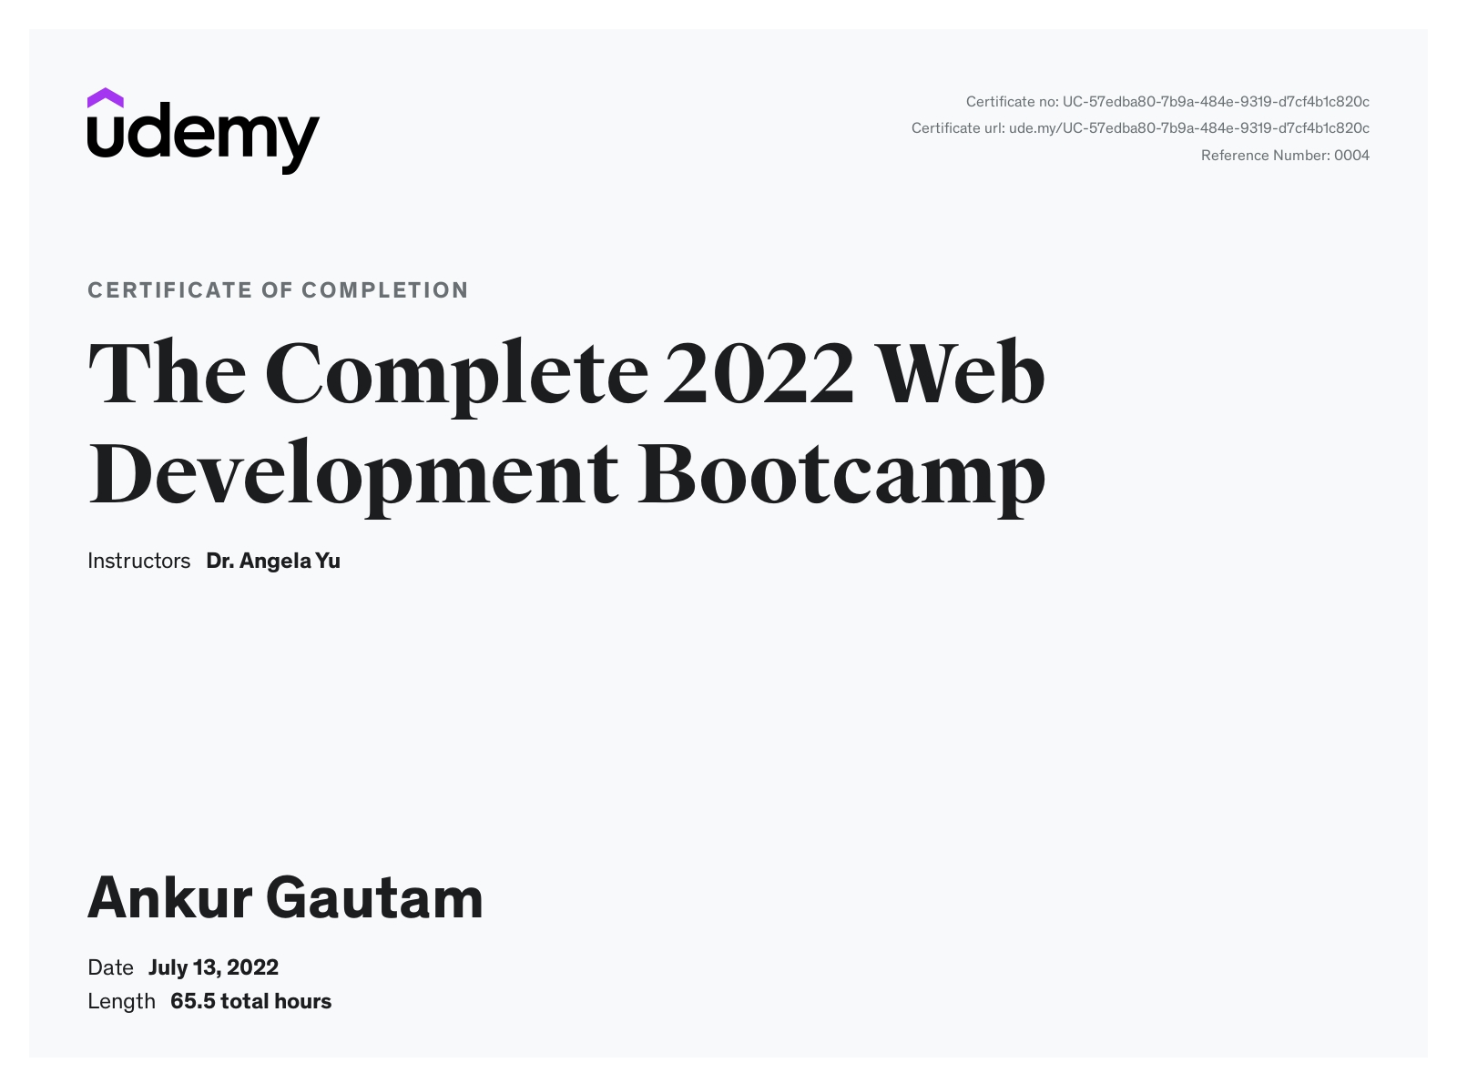



**ACKNOWLEDGEMENT**

We would like to express my gratitude towards **Mr. Mayank Saxena** for guiding us throughout the project. We also feel thankful and express our kind gratitude towards all our teachers for allowing us to conduct Philia – A Chat Application project. The mentioned project was done under the supervision of Mr. Mayank Saxena.

He has been helping us since Day 1 in this project. He provided us with the roadmap, the basic guidelines explaining on how to work on the project. He has conducted regular meeting to check the progress of the project and provided us with the resources related to the project. Without his help, we wouldn’t have been able to complete this project.

We feel thankful to the college staff for giving us such a big opportunity. I believe we will enrol in more such events in the coming future.

Name of Candidate- Ankur Gautam

University Roll No – 201500102

**ABSTRACT**

Conversation is a way of using technology to connect people with ideas outside of local boundaries. The technology has been available for years but adoption has only recently taken place.

My project is an example of chat application where we can chat and can do many more with our friends. To start chatting the user must be login where they can conduct private chat. Safety measures were taken at the last moment. The latest developments in the internet have brought the world into our hands. The internet makes the world a little round.

This paper highlights the importance of the use of dialogue in everyday life and its impact on the world of technology. This project is for the development of a chat system based on React JS programming language and Stream. This application is designed to communicate or chat with others online. React and Stream were used to develop this chatting application. This app is built with the right structures for future development.

**Content**

**Declaration**

**Certificate**

**Acknowledgement**

**Abstract**

**1. Introduction**

* 1. **Overview**
  2. **Project Planning**
  3. **Purpose**

**2. Software Requirement Analysis**

**2.1 Software requirement and specification**

**2.2 Tools used**

**2.3 Specific requirement**

**3. System Design**

**3.1 Design**

**3.2 System Information**

**3.3 System analysis**

**3.4 Feasibility analysis**

**3.5 Data flow diagram**

**4. Project Model View**

**4.1 Sign up**

**4.2 Sign in**

**4.3 Direct Chatting**

**4.4 Group Chatting**

**4.5 Create Group**

**4.6 Remove User**

**5. Code**

**6. Conclusion**

**References**

**Introduction**

**1.1 Overview**

Teleconferencing or Chatting is a method of using technology to bring people and ideas together despite of geographical barriers. The technology has been available for years but the acceptance was quite recent. This project is an example of chat application where we can chat and can do many other things with our friends. To start chatting the user must be login where they can conduct private chat. Safety measures were taken at the last moment. The latest developments in the internet have brought the world into our hands. The internet makes the world a little round. This project is also online.

The "Online Chat Application" has been developed to override the problems prevailing in the practicing manual system. This software is supported to eliminate and in some cases reduce the hardships faced by this existing system. Moreover this system is designed for the particular need of the company to carry out operations in a smooth and effective manner.

**1.2 Project Planning**

Project planning is part of project management, which relates to the use of schedules such as Gantt charts to plan and subsequently report progress within the project environment. Initially, the project scope is defined and the appropriate methods for completing the project are determined. Following this step, the durations forthe varioustasks necessary to complete the work are listed and grouped into a work breakdown structure. The logical dependencies between tasks are defined using an activity network diagram that enables identification of the critical path. Float or slack time in the schedule can be calculated using project management software. Then the necessary resources can be estimated and costs for each activity can be allocated to each resource, giving the total project cost. At this stage, the project plan may be optimized to achieve the appropriate balance between resource usage and project duration to comply with the project objectives. Once established and agreed, the plan becomes what is known as the baseline. Progress will be measured against the baseline throughout the life of the project

**1.3 Purpose**

A chat application makes it easy to communicate with people anywhere in the world by sending and receiving messages in real time. With a chat app, users are able to receive the same engaging and lively interactions through custom messaging features, just as they would in person. Automation of product manipulation.

**SOTWARE REQUIRMENT ANALYSIS**

**2.1 SOFTWARE REQUIREMENT AND SPECIFICATION:**

**VISUAL STUDIO:** Visual Studio Code is a streamlined code editor with support for development operations like debugging, task running, and version control. It aims to provide just the tools a developer needs for a quick code-build-debug cycle and leaves more complex workflows to fuller featured IDEs, such as Visual Studio IDE. Visual Studio Code is a lightweight but powerful source code editor which runs on your desktop and is available for Windows, macOS and Linux.

**WEB BROWSER:** A web browser (commonly referred to as a browser) is a software application for accessing information on the World Wide Web. Each individual web page, image, and video is identified by a distinct Uniform Resource Locator (URL), enabling browsers to retrieve these resources from a web server and display them on the user's device. The most popular browsers are Chrome, Firefox, Safari, Internet Explorer, and Edge.

**2.2 Tools Used**

**HTML:** Hypertext Markup Language (HTML) is the standard markup language for creating web pages and web application. With Cascading Style Sheets (CSS) and JavaScript, it forms a triad of cornerstone technologies for the World Wide Web.

Web Browser receive HTML documents from a web server or from local storage and render the documents into multimedia web pages. HTML describes the structure of a web page semantically and originally included cues for the appearance of the document.

HTML code ensures the proper formatting of text and images so that your Internet browser may display them as they are intended to look. Without HTML, a browser would not know how to display text as elements or load images or other elements. HTML also provides a basic structure of the page, upon which Cascading Style Sheets are overlaid to change its appearance. One could think of HTML as the bones (structure) of a web page, and CSS as its skin (appearance).

**CSS:** Cascading Style Sheets, fondly referred to as CSS, is a simple design language intended to simplify the process of making web pages presentable.

CSS handles the look and feel part of a web page. Using CSS, you can control the color of the text, the style of fonts, the spacing between paragraphs, how columns are sized and laid out, what background images or colors are used, layout designs,variations in display for different devices and screen sizes as well as a variety of other effects.

CSS is easy to learn and understand but it provides powerful control over the presentation of an HTML document. Most commonly, CSS is combined with the markup languages HTML or XHTML.

**JAVASCRIPT:** JavaScript often abbreviated as JS, is a high-level, interpreted programming

language that conforms to the ECMAScript specification. It is a programming language that is characterized as dynamic, weakly typed, prototype-based and multi-paradigm.

Alongside HTML and CSS, JavaScript is one of the core technologies of the World Wide Web. JavaScript enables interactive web pages and is an essential part of web applications. The vast majority of websites use it, and major web browsers have a dedicated JavaScript engine to execute it.

**REACTJS:** ReactJS is a **declarative**, **efficient**, and flexible **JavaScript library** for building reusable UI components. It is an open-source, component-based front end library which is responsible only for the view layer of the application. It was initially developed and maintained by Facebook and later used in its products like WhatsApp & Instagram.

The main objective of ReactJS is to develop User Interfaces (UI) that improves the speed of the apps. It uses virtual DOM (JavaScript object), which improves the performance of the app. The JavaScript virtual DOM is faster than the regular DOM. We can use ReactJS on the client and server-side as well as with other frameworks. It uses component and data patterns that improve readability and helps to maintain larger apps

**2.3 SPECIFIC REQUIRMENTS**

**Software Requirements:**

Operating System: Windows 8 and above

Front End : ReactJS

Backend: : Stream

Editor: : Visual Studio Code

Browsers: : Google Chrome and others

**Hardware Requirements:**

Processor : 1.8 GHz or faster processor

RAM : 2 GB

Hard disk : Minimum 20 GB free space

**SYSTEM DESIGN**

**3.1 Design**

The system has been designed using ReactJS technology and uses Stream for backend purpose.

**3.2 System Information**

This system is a chatting application. Through the application, user can add members, chat with other members, search new users, create groups and many more. The system has the following advantages:

* User friendly interface
* Fast access to chats
* Search facility
* Look and Feel Environment
* Group chatting
* Send photos, videos, documents, etc

**3.3 System Analysis**

System Analysis refers into the process of examining a situation with the intent of improving it through better procedures and methods. System Analysis is the process of planning a new system to either replace or complement an existing system. But before any planning is done the old system must be thoroughly understood and the requirements determined. System analysis is therefore, the process of gathering and interpreting facts, diagnosing problems and using the information to recomment improvements in the system. System analysis is conducted with the following objectives in mind:

Evaluate the system concept for feasibility.

Perform economic and technical analysis.

Allocate functions to hardware, software people, database and other system elements.

Establish cost and schedule constraints.

Create a system definition that forms the foundation for all the subsequent engineering work.

**3.4 Feasibility Analysis**

Whatever we think need not be feasible. It is wise to think about the feasibility of any problem we undertake. Feasibility is the study of impact, which happens in the organization by the development of a system. The impact can be either positive or negative. When the positives nominate the negatives, then the system is considered feasible. Here the feasibility study can be performed in two ways such as technical feasibility and Economical Feasibility.

**Technical Feasibility**

It is technically feasible, since there will not be much difficulty in getting required resources for the development and maintaining the system as well.

All the resources needed for the development of the software as well as the maintenance.

**3.5 DATA FLOW DIAGRAM**

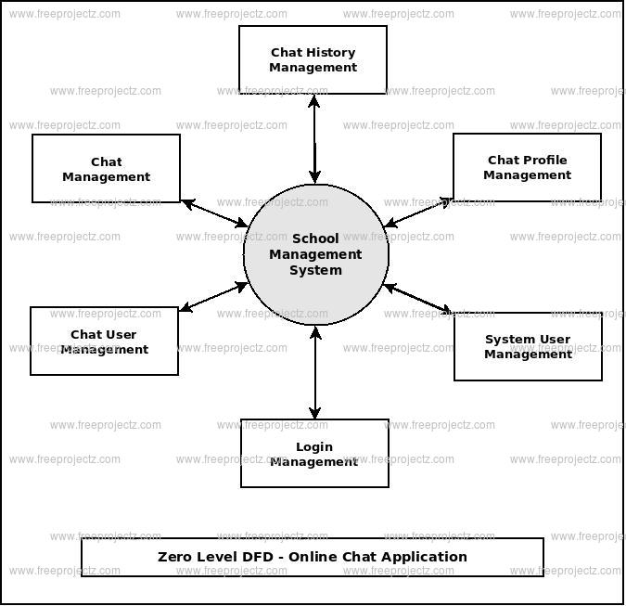

**PROJECT MODEL VIEW**

**4.1 Sign Up:**

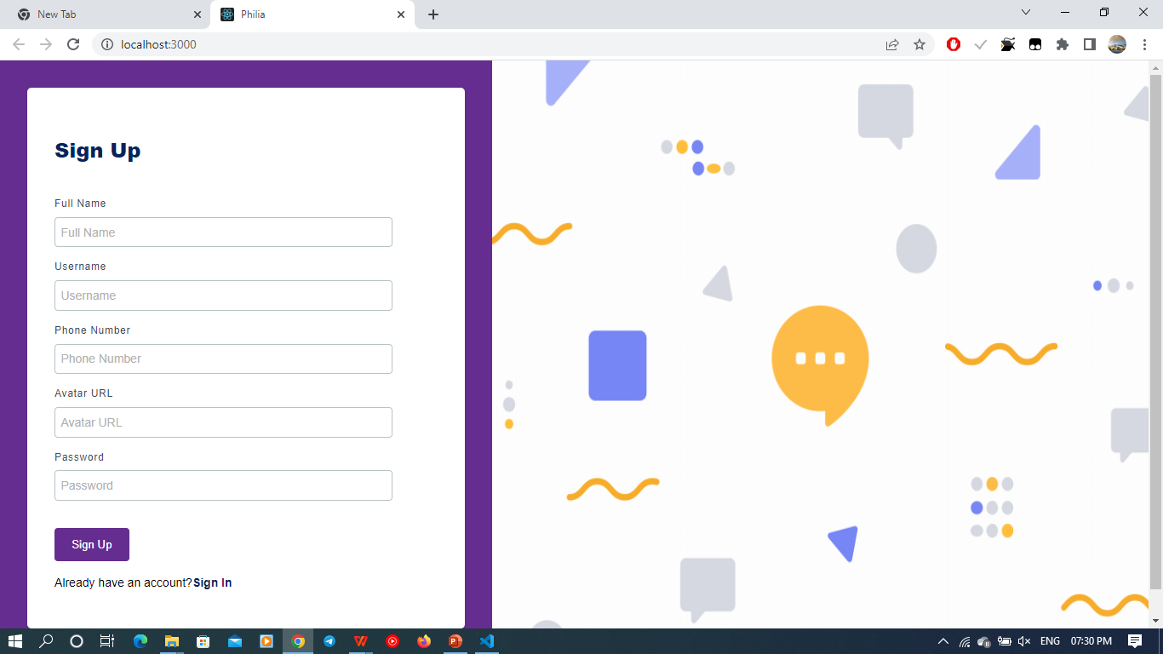

**4.2 Sign in:**

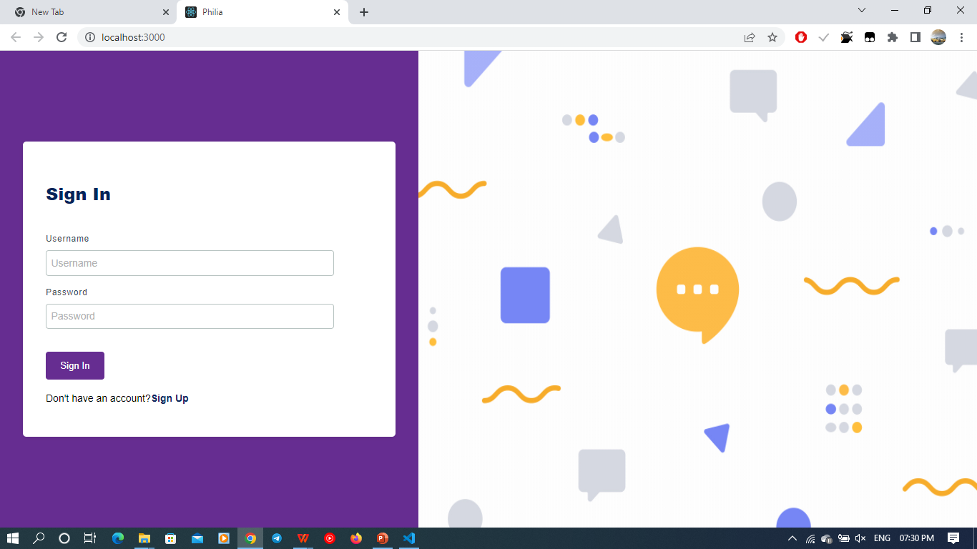

**4.3 Direct Chatting:**

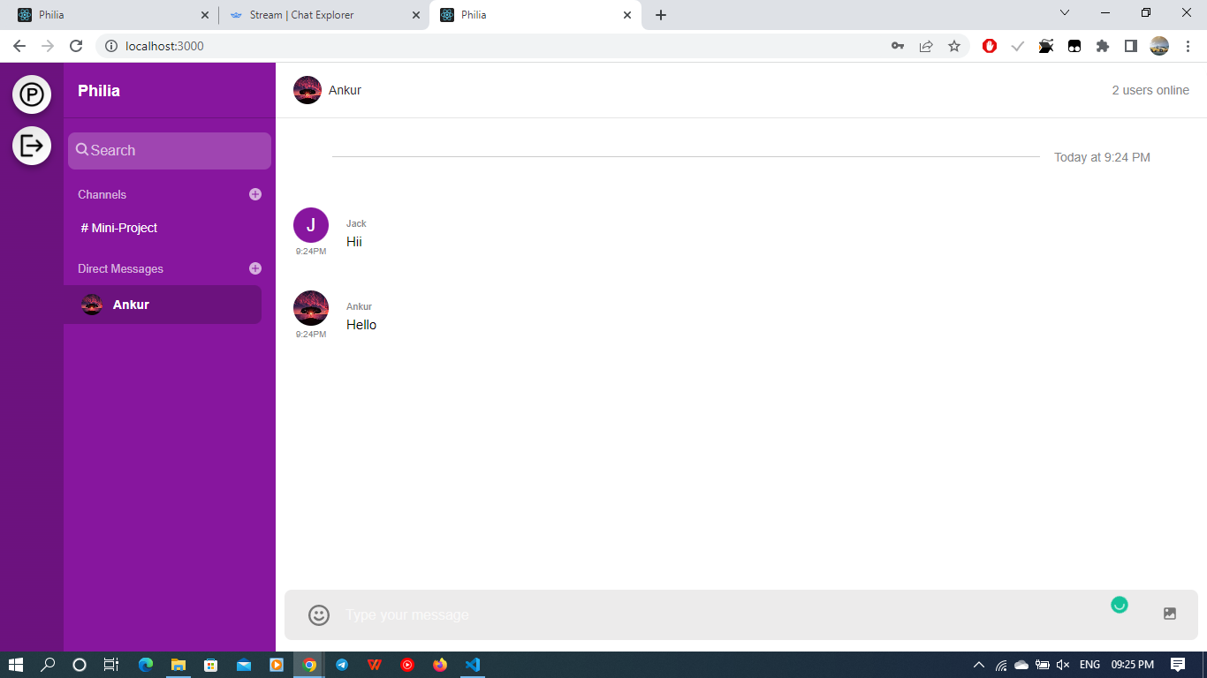

**4.4 Group Chatting:**

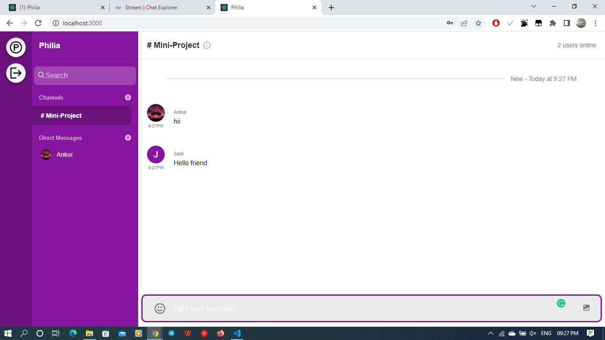

**4.5 Create group:**

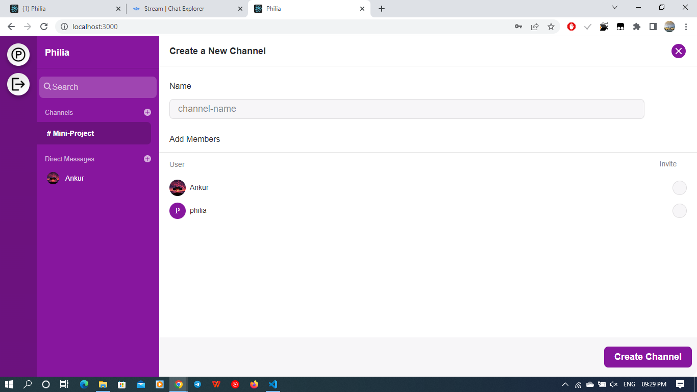

**4.6 Remove Users;**

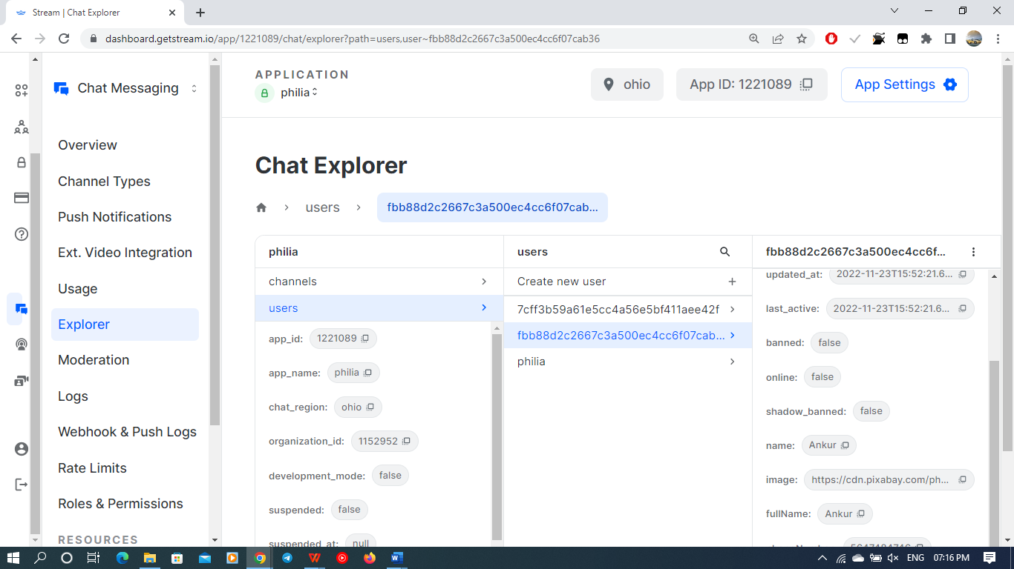

**Code:**

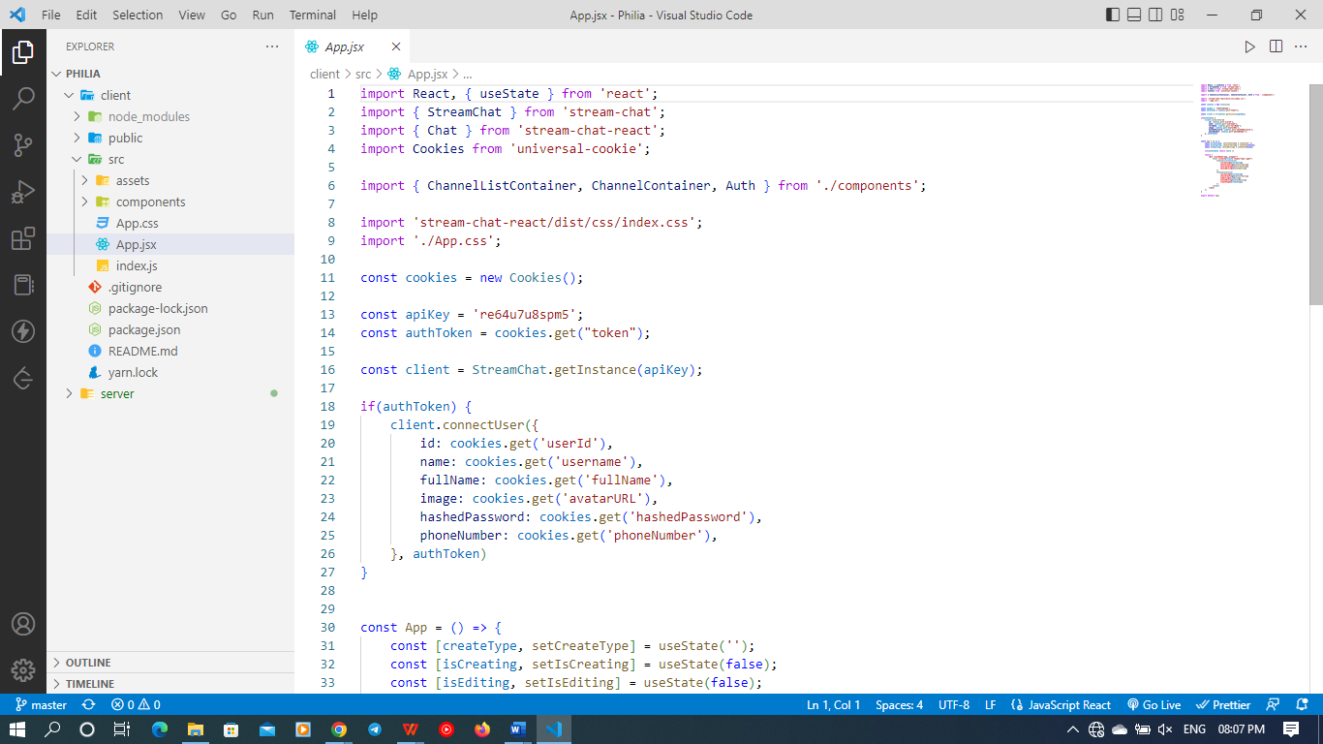

**Remaining code:**

<https://github.com/Ankur357/Philia-A-chat-application>

**Conclusion**

React JS is one of the most popular and powerful front-end technology around the world, today. It offers excellent performance in any application. In addition to this, React JS offers good compatibility on different platforms, browsers and devices. After developing the Chat App, it is clear that React JS is an easy to learn and convenient to implement.

The chat app provides a better and more flexible chat system. Developed with the latest technology in the way of providing a reliable system. The main advantage of the system is instant messaging, real-world communication, added security, group chat, etc.

**PROJECT GITHUB LINK:** <https://github.com/Ankur357/Philia-A-chat-application>

**REFERENCES**

* <https://tutorialspoint.com/>
* <http://javatpoint.com/>
* <http://code.visualstudio/>
* <https://getstream.io/>
* <http://youtube.com/>